Preliminary Design

Requested by: Dr. Darren Lim
Assistant Professor
Department of Computer Science
Siena College

Mrs. Pauline White
Visiting Instructor
Department of Computer Science
Siena College

Generation Java

ID – 10t Consultants

Prepared by: Kevin Mulchay
Christine Fox
Nick Miller
Jordan Steans

December 1, 2008
Generation Java
Preliminary Design

Table of Contents

I. Product Overview and Summary …………………………………………………………….3
II. External Design Specifications
Detailed Data Flow Diagrams………………………………………………………………………3
Prototype Screens...………………………………………………………………………………..….3
Logical Data Dictionary…..…………………………………………...................................4

III. Architectural Design Specification
Structure Diagrams (Hierarchy Diagram)…………………………………………………….7

IV. Testing Requirements
Requirements Inventory…………………………………………………………………………….8
Unit Tests……………..………………………………………………………………………………….14

Section 1: Product Overview and Summary

Students learn best through practice and application of course materials. Generation Java will provide students with the ability to practice, complete homework assignments, take quizzes and test, in an input based web application that will compile and run the student’s Java code for instantaneous feedback. Instructors will be able to create question sets and allow student access as well as being able to offer more practice for students. Administrators will manage, update, and maintain this application management system.

Section 2: External Design Specifications

Detailed Data Flow Diagrams
(see attached document)

Prototype Screens (see attached document)

Logical Data Dictionary
ID-10t Consulants
Data Dictionary
 |  |  |  |  | Date: 11/20/08
TABLE | COLUMN | DATA TYPE | DESCRIPTION | NOTES | VALIDATION
students | std_id | VARCHAR(8) | Siena College network login  -first & middle initial  -the day of the month you were born (two digits)  -the first four letters of your last name | Required: Primary Key  Varations/Exceptions:  -If you have no middle initial, just skip it  -if you have an apostrophie in your name (e.g., O'Brien), leave it out  -if your last name is less than four letters, write what you have | AlphaNumeric  -option 1: two chars, two digits, & at least two chars  -option 2: one char, two digits, & at least two chars
students | std_email | VARCHAR(30) | student's e-mail address
students | std_fname | VARCHAR(20) | student's first name
students | std_lname | VARCHAR(20) | student's last name
students | std_password | VARCHAR(15) | student's password | Chosen by student at account creation. Passwords must be a minimum length of 8 characters | AlphaNumeric
instructor | inst_id | VARCHAR(8) | Siena College network login  -first & middle initial  -the day of the month you were born (two digits)  -the first four letters of your last name | Required: Primary Key  Created by system administrator at account creation | AlphaNumeric  -option 1: two chars, two digits, & at least two chars  -option 2: one char, two digits, & at least two chars
instructor | inst_email | VARCHAR(30) | instructor's e-mail address
instructor | inst_fname | VARCHAR(20) | instructor's first name
instructor | inst_lname | VARCHAR(20) | instructor's last name
instructor | inst_password | VARCHAR(15) | instructor's password | Chosen by system administrator at account creation. Passwords must be a minimum length of 8 characters | AlphaNumeric
sys_adm | sys_id | VARCHAR(10) | system administrator's login user id | Chosen by the system administrator
sys_adm | sys_email | VARCHAR(30) | system administrator's e-mail address
sys_adm | sys_fname | VARCHAR(20) | system administrator's first name
sys_adm | sys_lname | VARCHAR(20) | system administrator's last name
sys_adm | sys_password | VARCHAR(15) | system administrator's password | Chosen by the system administrator. Passwords must be a minimum length of 8 characters | AlphaNumeric
prg_adm | prg_id | VARCHAR(8) | Siena College network login  -first & middle initial  -the day of the month you were born (two digits)  -the first four letters of your last name | Required: Primary Key  Created by system administrator at account creation | AlphaNumeric  -option 1: two chars, two digits, & at least two chars  -option 2: one char, two digits, & at least two chars
prg_adm | prg_email | VARCHAR(30) | program administrator's e-mail address
prg_adm | prg_fname | VARCHAR(20) | program administrator's first name
prg_adm | prg_lname | VARCHAR(20) | program administrator's last name
prg_adm | prg_password | VARCHAR(15) | program administrator's password | Chosen by the system administrator at account creation. Passwords must be a minimum length of 8 characters | AlphaNumeric
prg_adm | prg_course | VARCHAR(10) | program administrator coordinates the specified course, section-wide | Chosen by the system administrator at account creation
course | course_number | VARCHAR(10) | course subject followed by course number and section number | Required: Primary Key  Ex. CSIS220-10
course | course_name | VARCHAR(30) | course name
course | semester | VARCHAR(10) | semester in which the course is offered | Chosen by the system administrator at course creation
course | course_inst | VARCHAR(20) | course instructor
course | course_pw | VARCHAR(15) | course password | Chosen by the system administrator at course creation | AlphaNumeric
question_set | set_name | VARCHAR(20) | question set name
question_set | set_type | VARCHAR(8) | question set type | Question Set types are:  -homework  -quiz  -test  -practice
question_set | size | NUMBER | number of questions in a question set
published_set | set_name | VARCHAR(20) | question set name
published_set | time_avail | TIME | the time the question set becomes available | Chosen at publication of the question set
published_set | time_due | TIME | the time the question set is due or becomes unavailable | Chosen at publication of the question set
published_set | date_avail | DATE | the date the question set becomes available | Chosen at publication of the question set
published_set | date_due | DATE | the date the question set is due or becomes unavailable | Chosen at publication of the question set
published_set | time_limit | TIME | how long a user has to submit the question set once the user has started answering the question set | Chosen at publication of the question set. This is an optional field and can be left empty
published_set | num_of_attempts | NUMBER | the number of attempts a user has per question | Chosen at publication of the question set
published_set | late_submission | VARCHAR(3) | whether a published question set accepts late submissions | Chosen at publication of the question set. Yes or No will be entered into this field
published_set | visible | VARCHAR(3) | whether a published question set is visible to users after the date and time due | Chosen at publication of the question set. Yes or No will be entered into this field
question | qst_title | VARCHAR(30) | question title
question | qst_category | VARCHAR(10) | question category | Categories are:  -loops  -arrays
question | question | TEXT | the question | Can be added through an uploaded file
question | signature | VARCHAR(80) | method signature for the question
question | test_cases | TEXT | viewable test cases for the question | Can be added through an uploaded file
question | hidden_test_cases | TEXT | hidden test cases for the question | Can be added through an uploaded file and is also an optional field that can be left empty
question | solution | TEXT | question solution | Can be added through an uploaded file
question | recursive | VARCHAR(3) | whether the question should be answered recursively | Yes or No will be entered into this field
question | hints | TEXT | question hints | An optional field, can be left empty
gradebook | course | VARCHAR(10) | course subject followed by course number and section number
gradebook | date | DATE | date of an assignement
gradebook | assignment_name | VARCHAR(20) | name of an assignment
gradebook | pts_earned | NUMBER | number of points earned on an assignment
gradebook | point_total | NUMBER | total number of points that can be earned on an assignment
gradebook | category | VARCHAR(20) | category of the assignment
gradebook | weight | PERCENT | the weight of an assignment used to calculate a users' overall grade
private_pool | qst_set | VARCHAR(20) | name of a question set
private_pool | size | NUMBER | number of question sets in a private pool
course_pool | qst_set | VARCHAR(20) | name of a question set
course_pool | size | NUMBER | number of question sets in a course pool
global_pool | qst_set | VARCHAR(20) | name of a question set
global_pool | size | NUMBER | number of question sets in the global pool
bulletin | announcements | TEXT | announcements found on the home screen bulletin

Section 3: Architectural Design Specification

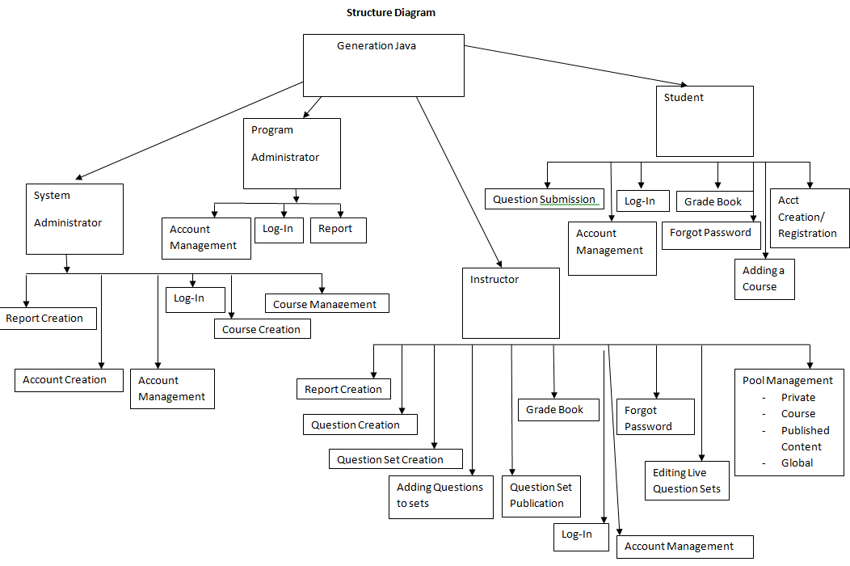

Section 4: Testing Requirements

Requirements Inventory

Functional Requirements
Requirements grouped according to Use Case.
System Administrator:
There is only one System Administrator.
Once logged in, a System Administrator has three views available:
- Student
- Instructor
- Administrator

The System Administrator can perform different tasks based on which view is currently be used:

Student View
- Registration
- The System Administrator views the system as a Student that is registered in all possible courses.
- The System Administrator is not seen as registered for any course by any user.
- The System Administrator does not need to log out to switch between courses.

- Questions/Question Sets
- The System Administrator is able to attempt any question set, including all homework, quiz, test, and practice sets for any section of any course by having the same functionality a student would have in attempting a question set.
- The System Administrator is able to save code to a database.
- Once code is compiled and executed, the System Administrator will receive feedback on it.
- The feedback received by the System Administrator is identical to that of a Student; however, it is not viewable by any Instructor.
- The System Administrator’s grades are not counted in any reports, including reports run by an Administrator.
- The System Administrator should be aware when the maximum number of attempts (if specified) has been reached on a question, but should not be restricted by it as a Student would be.
- The System Administrator has the ability to click any links (if provided and enabled) on any question.
- The System Administrator can view all files posted by all Instructors.

Instructor View
- Registration
- The System Administrator views the system as an Instructor that is instructing all possible courses.
- The System Administrator is not seen as an Instructor of any course by any user.
- The System Administrator does not need to log out to switch between courses.
- Questions/Question Sets
- The System Administrator can create, edit, delete, and distribute all questions and question sets.
- The System Administrator can set a time and date for any question set to become available.
- The System Administrator can set a time and date for any questions set to be due.
- The System Administrator can assign point totals to any question set.
- Instructor Privileges
- The System Administrator can see all Students’ last submissions and submission information for every (attempted) question in every question set.
- The System Administrator can see all Students’ statistics (including login information) and all statistics for every question in every question set.
- Statistics will be provided in a report that can be requested by the System Administrator.

Administrator View
- The System Administrator can create, edit, and delete the following types of accounts:
- Program Administrator
- Instructor
- Student

- Editing an account consist of changing a user’s account type, e-mail, password and courses taught or enrolled in.
- The System Administrator can add questions/question sets to the global pool.
- The System Administrator may logout in any view.

Program Administrator:
A Program Administrator coordinates one more sections/courses.
There may be multiple Program Administrators.
Program Administrators do not register.
A Program Administrator’s account is created by the System Administrator.

Once logged in, a System Administrator has three views available:
- Student
- Instructor
- Administrator
A Program Administrator can perform different tasks based on which view is currently be used:

Student View
- Registration
- A Program Administrator views the system as a Student that is registered in all courses specified by the System Administrator.
- A Program Administrator is not seen as registered for any course by any user except by the System Administrator.
- A Program Administrator does not need to log out to switch between courses.

- Questions/Question Sets
- A Program Administrator is able to attempt any of the question sets specified by the System Administrator, including homework, quiz, test, and practice sets.
- A Program Administrator is able to save code to a database.
- Once code is compiled and executed, A Program Administrator will receive feedback on it.
- The feedback received by a Program Administrator is identical to that of a Student; however, it cannot be viewed by any Instructor.
- A Program Administrator’s grades are not counted in any reports, including reports run by an Administrator.
- A Program Administrator should be aware when the maximum number of attempts (if specified) has been reached on a question, but should not be restricted by it as a Student would be.
- A Program Administrator has the ability to click any links (if provided and enabled) on any question specified by the System Administrator.
- A Program Administrator can view all files posted by Instructors specified by the System Administrator.

Instructor View
- Registration
- A Program Administrator views the system as an Instructor that is instructing all courses specified by the System Administrator.
- A Program Administrator is not seen as an Instructor of any course by any user.
- A Program Administrator does not need to log out to switch between courses.
- Questions/Question Sets
- A Program Administrator can create, edit, delete, and distribute course-specific questions and question sets.
- A Program Administrator can set a time and date for any question set specified by the System Administrator to become available.
- A Program Administrator can set a time and date for any questions set specified by the System Administrator to be due.
- A Program Administrator can assign point totals to any question set specified by the System Administrator.
- Instructor Privileges
- A Program Administrator can see all Students’ (specified by the System Administrator) last submissions and submission information for every (attempted) question in every question set.
- A Program Administrator can see all Students’ (specified by the System Administrator) statistics (including login information) and all statistics for every question in every question set (also specified by the System Administrator).

Administrator View

- A Program Administrator can create, edit, and delete the following types of accounts:
- Instructor
- Student
- The Program Administrator can add question/question sets to any of the course-specific pools specified by the System Administrator.
- The Program Administrator may logout in any view.

Instructor:
An Instructor does not register.
An Instructor’s account is created by a Program Administrator or the System Administrator.
Once logged in, an Instructor has two views available:
- Student
- Instructor

An Instructor can perform different tasks based on which view is currently be used:

Student View
- Registration
- An Instructor views the system as a Student that is registered in all courses specified by the Program Administrator.
- An Instructor is not seen as registered for any course by any user.
- An Instructor does not need to log out to switch between courses.

- Questions/Question Sets
- An Instructor is able to attempt any of the question sets specified by the Program Administrator, including homework, quiz, test, and practice sets.
- An Instructor is able to save code to a database.
- Once code is compiled and executed, an Instructor will receive feedback on it.
- The feedback received by an Instructor is identical to that of a Student. No one else can view this feedback.
- An Instructor’s grades are not counted in any reports, even reports run by an Administrator.
- An Instructor should be aware when the maximum number of attempts (if specified) has been reached on a question, but should not be restricted by it as a Student would be.
- An Instructor has the ability to click any links (if provided and enabled) on any question specified by the Program Administrator.
- An Instructor can view all files posted by themselves or other Instructors specified by the Program Administrator.

Instructor View
- Registration
- An Instructor can view all courses specified by a Program Administrator.
- An Instructor is seen as the Instructor for all courses specified by the Program Administrator.
- An Instructor does not need to log out to switch between courses.
- If an Instructor wishes to teach a new course, the new course may be added by inputting the Course ID into the appropriate location. A Course ID is provided by the Program Administrator or System Administrator.
- Questions/Question Sets
- An Instructor has the ability to create, edit, and delete java questions in the Instructor’s own private pool.
- An Instructor can upload a question or enter it into a text box.
- An Instructor may provide links to aid a Student.
- An Instructor has the ability to create, edit and delete question sets in the Instructor’s own private pool.
- An Instructor can use questions from the Instructor’s private pool, the course-specific pool, or the global pool when creating question sets.
- When creating a question set, an Instructor can set point totals and a maximum number of attempts allowed for each question.
- An Instructor can set a time and date for a question set to become available and unavailable.
- If an Instructor wishes to add a question or question set to the course-specific pool, it must be submitted to the Program Administrator.
- If an Instructor wishes to add a question or question set to global pool, it must be submitted to the System Administrator.
- Instructor Privileges
- An Instructor can see all Students’ (registered in the Instructor’s course) last submissions and submission information for every (attempted) question in every question set.
- An Instructor can see all Students’ (registered in the Instructor’s course) statistics (including login information) and all statistics for every question in every question set (also in the Instructor’s course).
- These statistics (which include grade information) can be generated into reports and exported to a tab delimited or .pdf file.
- An Instructor may edit a Student’s grade as seen fit.
- An Instructor may deny a student access to a course.
- An Instructor may post files that can be viewed by Students in the Instructor’s course.

An Instructor can log out in either view.

Student:
A Student has only one view.

- Registration
- A Student must register in a specific course by entering a Course ID in the appropriate location.
- A Course ID is provided by the Instructor of that course.
- A Student may be registered in multiple courses under the same username and password.
- A Student does not need to log out in order to change which course is currently being worked in.
- Question Sets
- A Student has the ability to view and attempt any question set provided by the Instructor.
- When a Student submits code, feedback is returned indicating the code’s degree of correctness.
- A Student can retry a question until the number of attempts (if specified) has run out.
- A Student may see only their own grades and statistics.
- Additional Privileges/Restrictions
- A Student may view any link or file provided by the Instructor (if enabled).
- A Student may not click out of the testing window during a test or the test will be terminated.
- A Student may log out as desired.

Non Functional Requirements
- The system should run quickly, using fast servers and databases.
- The system should be user-friendly.

Section 4: Unit Tests (see attached document)

